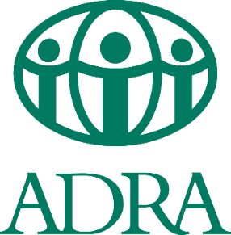

ADRA Sudan- West Darfur -Geneina Office
BRIGHT Project
Request for Proposal (RFP)
Ref:00016- FY22
The closing date for the above-mentioned tender has been extended to Sunday 14th August 2022
ADRA Sudan, on behalf of partners, is inviting a qualified consultant to lead the facilitate the midterm review focused workshops, lead data collection (focus group discussions and key informant interview) at field and draft the mid-term review report for BRIGHT project, prepare a report for BRIGHT Project (Breaking Barriers, Improving Girls’ Education, Hope and Totality).
ADRA Sudan hereby invites all interested and capable consultants to collect the tender documentations, including Terms of Reference, and selection criteria, can be obtained from ADRA Khartoum Office located at House 64, Block 18, Ebn Alwaleed Street, Riyadh City-Khartoum.

The offers proposals are to be submitted in a sealed and stamped envelopes and posted in the tender box at ADRA SUDAN Khartoum office. clearly marked with (ADRA SUDAN/Consultancy Service Peer Reviewer). The tender documents will be available free of charge from ADRA SUDAN Khartoum office
The closing date of the tender was July 6, 2021, due to the request, the closing date has been extended till Sunday, 14 August 2022 at 4:00 pm
For any clarification or inquiries on this particular tender, please contact the following number or email
0903719160 - Email: logistics@adrasudan.org /zaid.muhaied@adrasudan.org

